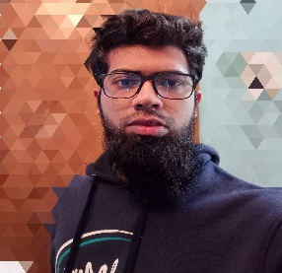

**Skills**

**Technical Skills**

* C++
* Python
* JavaScript
* React JS
* Node JS
* Express JS
* HTML
* CSS
* Bootstrap

**Projects**

* **Book Library** - A website built using Node JS as backend and HTML, CSS for frontend
* **Counter App** - A single page app built using React JS
* **Country Search** - A page built using React JS with 3rd party API fetching
* **Task manager api** - It’s built using Node JS
* **Store api** – It’s built using Node JS

**Education**

Graduation

Dhaka University of Engineering and Technology, Gazipur

Computer Science and Engineering – CGPA 2.87 / 4.0

[Github Link](https://github.com/Talalmahmud)

**Non- Technical Skills**

* Communication
* Team work skills
* Time management
* Problem solving

**Talal Mahmud**

Majirkhula,Simultali Road, Gazipur

[mahmudtalal2@gmail.com](mailto:mahmudtalal2@gmail.com)

+880179-5257742



[Linkdin Link](https://www.linkedin.com/in/talal-mahmud-28043b255/)

**Summary**

As a JavaScript developer with excellent time management abilities and learning attitude. Inclined towards the field of web development and interested in the area of MERN web development.